Shiyi Li

CSCI 4707

ID: 4576123

A.

B.

1. 1. DBMS protects the user from the system failure

2. Applications are independent from data representation

3. DBMS enforce integrity constraints and access control

2. 1.Requirement analysis: discuss with customer and Understand what are the requirements, how different entities relate to each other, what are the frequent operations to be performed.

2.Conceptual Database Design: Develop a high-level description of the data and develop an ER (entity-relationship) model that captures the semantics of the data.

3.Logical Database Design: Convert the ER model into a (relational) database schema.

4.Scheme Refinement: Identify potential problems in your schema design.

5.Physical Database Design: Study the expected workload of the system, and Tune the performance by building indexes and clustering tables.

6.Application and Security Design: Identify which parts of the database are accessible to whom.

C.

1.

a.

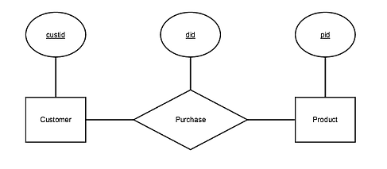

b.

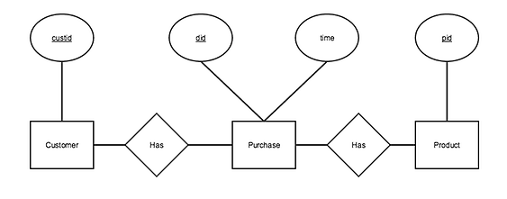

c.

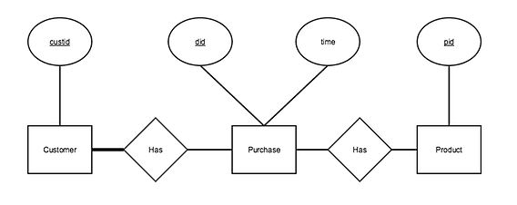

d.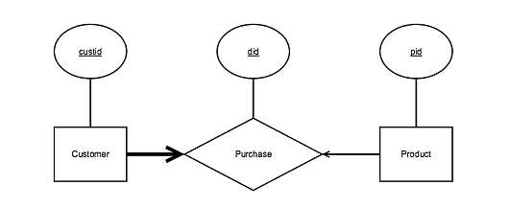

2.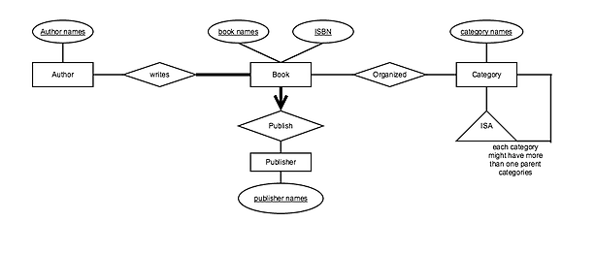

3.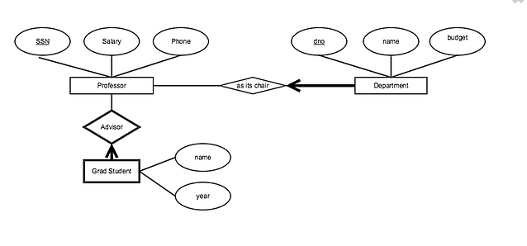

4.